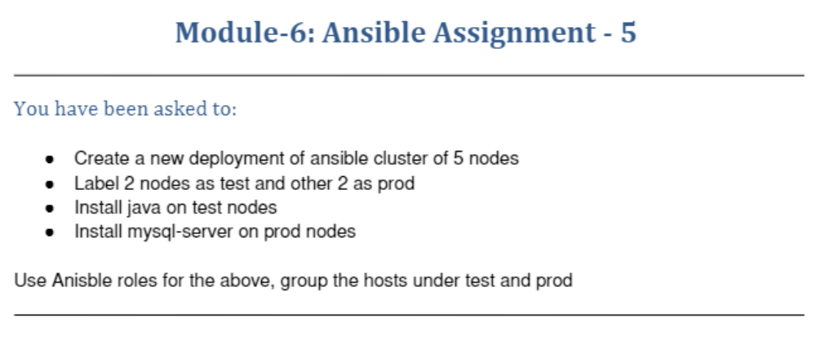
ubuntu@ip-172-31-16-129:~/ansible$ sudo vi hosts
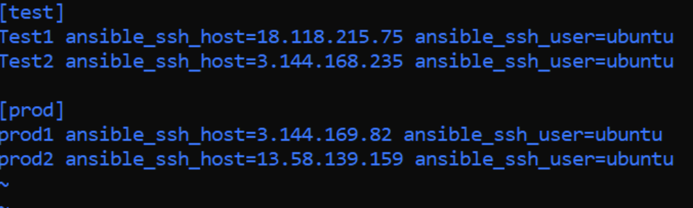
ubuntu@ip-172-31-16-129:~/ansible$ sudo vi myplaybook.yaml
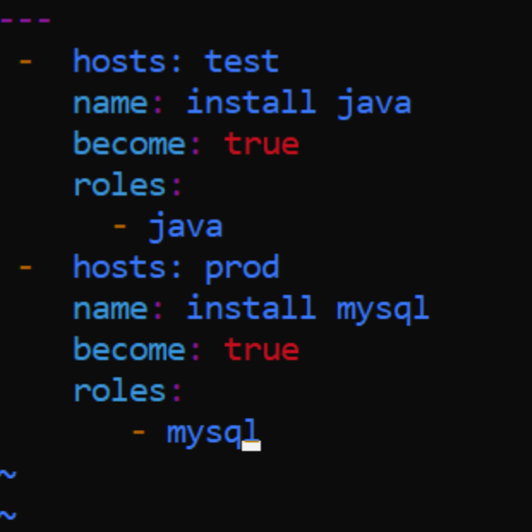

ubuntu@ip-172-31-16-129:~/ansible$ ls
hosts myplaybook.yaml roles
ubuntu@ip-172-31-16-129:~/ansible$ cd roles
ubuntu@ip-172-31-16-129:~/ansible/roles$ cd java/
ubuntu@ip-172-31-16-129:~/ansible/roles/java$ cd tasks
ubuntu@ip-172-31-16-129:~/ansible/roles/java/tasks$ sudo vi main.yml
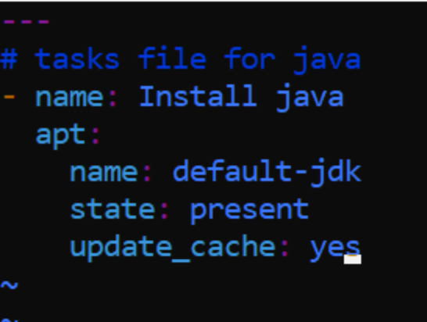
ubuntu@ip-172-31-16-129:~/ansible/roles/java/tasks$ cd ..
ubuntu@ip-172-31-16-129:~/ansible/roles/java$ cd ..
ubuntu@ip-172-31-16-129:~/ansible/roles$ ls
java mysql
ubuntu@ip-172-31-16-129:~/ansible/roles$ cd ..
ubuntu@ip-172-31-16-129:~/ansible$ sudo vi myplaybook.yaml
ubuntu@ip-172-31-16-129:~/ansible$ cd roles
ubuntu@ip-172-31-16-129:~/ansible/roles$ cd mysql/
ubuntu@ip-172-31-16-129:~/ansible/roles/mysql$ cd tasks/
ubuntu@ip-172-31-16-129:~/ansible/roles/mysql/tasks$ sudo vi main.yml
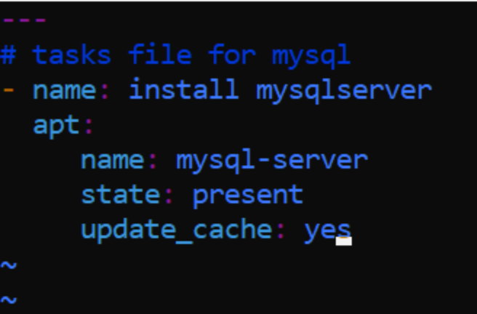
ubuntu@ip-172-31-16-129:~/ansible/roles/mysql/tasks$ sudo vi myplaybook.yaml
ubuntu@ip-172-31-16-129:~/ansible/roles/mysql/tasks$ ls
main.yml
ubuntu@ip-172-31-16-129:~/ansible/roles/mysql/tasks$ cd ..
ubuntu@ip-172-31-16-129:~/ansible/roles/mysql$ cd ..
ubuntu@ip-172-31-16-129:~/ansible/roles$ cd ..
ubuntu@ip-172-31-16-129:~/ansible$ ls
hosts myplaybook.yaml roles
ubuntu@ip-172-31-16-129:~/ansible$ sudo vi myplaybook.yaml
ubuntu@ip-172-31-16-129:~/ansible$ ansible-playbook -i hosts myplaybook.yaml

PLAY [install java] ******************************************************************************************************

TASK [Gathering Facts] ***************************************************************************************************
ok: [Test2]
ok: [Test1]

TASK [java : Install java] ***********************************************************************************************
changed: [Test2]
changed: [Test1]

PLAY [install mysql] *****************************************************************************************************

TASK [Gathering Facts] ***************************************************************************************************
ok: [prod2]
ok: [prod1]

TASK [mysql : install mysqlserver] ***************************************************************************************
changed: [prod1]
changed: [prod2]

PLAY RECAP ***************************************************************************************************************
Test1 : ok=2 changed=1 unreachable=0 failed=0 skipped=0 rescued=0 ignored=0
Test2 : ok=2 changed=1 unreachable=0 failed=0 skipped=0 rescued=0 ignored=0
prod1 : ok=2 changed=1 unreachable=0 failed=0 skipped=0 rescued=0 ignored=0
prod2 : ok=2 changed=1 unreachable=0 failed=0 skipped=0 rescued=0 ignored=0
ubuntu@ip-172-31-16-129:~/ansible$

